CYL3D: A Matlab® Function to Plot 3-Dimensional Data on
a Cylindrical Surface

J M De Freitas
QinetiQ Ltd, Winfrith Technology Centre
Winfrith, Dorchester
Dorset DT2 8XJ
United Kingdom

16 September 2005

Occasionally one is required to plot intensity or magnitude information obtained along the radial or axial direction on a cylindrical surface. This technical note describes CYL3D, a Matlab® function that allows the user to plot 3-Dimensional data on the curved surface of a cylinder. Typical applications include shape, stress and temperature profiles obtained for internal and external pipes, and modelling involving cylindrical structures. CYL3D is similar to POLAR3D, where the latter is 3D information plotted over a disc.

Terms and Conditions of Use

- This function is made available to Matlab® users under the terms and conditions set out in the Matlab Exchange by The Mathworks, Inc.
- Where the use of CYL3D is to be cited, the following is recommended:
J M De Freitas. ‘CYL3D: A Matlab® Function to Plot 3-Dimensional Data on a Cylindrical Surface’. QinetiQ Ltd, Winfrith Technology Centre, Winfrith, Dorchester DT2 8XJ. UK. 16 September 2005.
- No offer of warranty is made or implied by the author and use of this work means that the user has agreed to take full responsibility for its use.

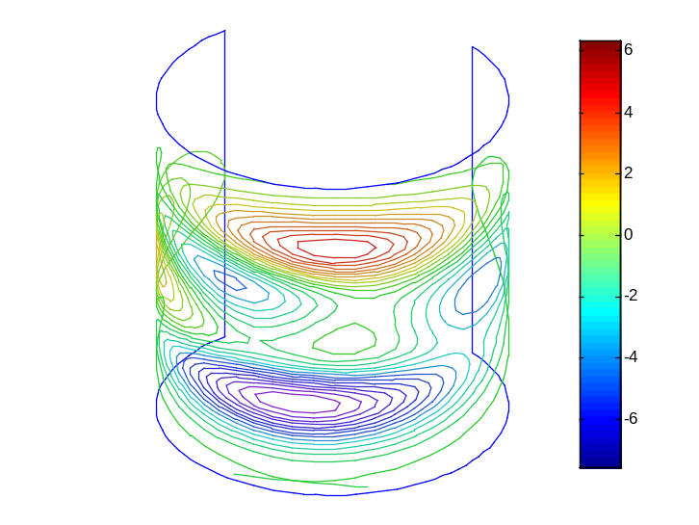
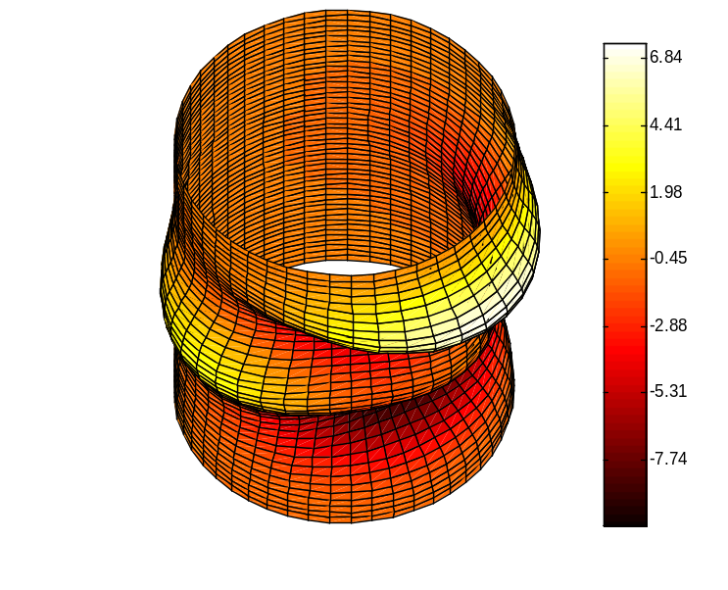
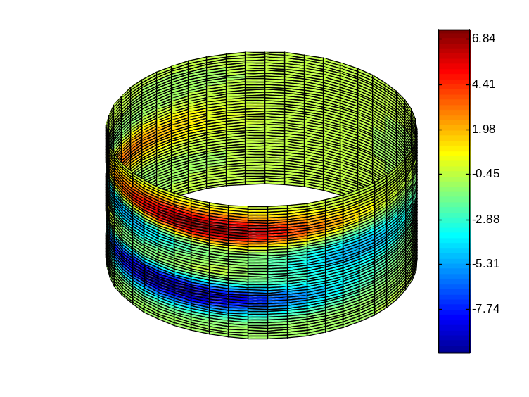
MESH PLOT
CONTOUR
SURF HOT MAP
SURF / FILLED CONTOUR
3D PLOTS ON A CYLINDRICAL SURFACE

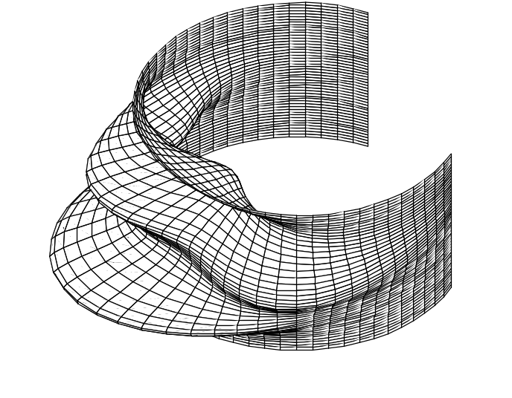

Mesh Plot
The mesh plot shown above was produced using:

P = peaks(20);
cyl3d(P,-pi/2,pi,20,20,.4,'spline',1.5);

In this case the angular range covers -90º to 180º, at radius 20, with cylinder height 20. The spline interpolation method was used to increase the dimension of the input matrix from 20x20 to 50x50 using a mesh scale value of 0.4. The peaks and valleys are magnified by 50% using a Zscale factor of 1.5.

Contour Plot
The contour plot shown above was produced using:

P = peaks(20);
cyl3d(-P,-pi/2,pi,20,40,.4,'contour','spline');

The angular range and radius are unchanged from the previous example above. The height is changed to 40. Note that the range of the peaks and valleys shown on the contour are unaffected by Zscale. Note further that the colour scheme of the contour plot is unaffected by the colormap command. See Surf Plot below. Moreover, when the angular range is 360º, a vertical line on the cylindrical surface is used to show the reference or start point.

Surf Plot
The surf plot is slightly different to the standard Matlab surf plot. In CYL3D the colour intensity varies radially from inside (lowest value) to outside (highest value). This allows the user to easily spot peaks and troughs on the surface.

The surf plots produced by this function accept the colormap command. For example, the hot scale plot shown above was produced using:

P = peaks(20);
cyl3d(-P,-pi,pi,20,40,.4,'surf','spline');
colormap hot

Any standard colour mapping could be used. Note that there is no reference line in the surf plot when plotted over 360º as in the contour plot. The output (x,y,z,c) can be used as in

P = peaks(20);
[x,y,z,c] = cyl3d(-P,-pi/2,pi,20,40,.4,'off','spline',.001);
surf(x,y,z,c)

to produce a surf plot with colour mapping c as in the CYL3D ‘surf’ option. Standard properties, e.g. axes, axis labels, title, etc. for the plot can then be manipulated to suit the user.

Surf / Filled Contour Plot
The surf plot function could be used to produce a map similar to a filled contour plot. This is done by either scaling up the height and radius simultaneously, or preferably, using the Zscale factor. Using a small value for Zscale means that peaks and troughs are not noticeable on the plot giving the impression of a filled contour plot e.g. Zscale is 0.005.

P = peaks(20);
cyl3d(-P,-pi,pi,20,20,.4,'surf','spline',.005);

Function Description
A detailed description of the function can be found from the standard help command – help cyl3d – or the header information in the file cyl3d.m.

